HackerEarth Program 5
Link :- https://www.hackerearth.com/practice/basic-programming/input-output/basics-of-input-output/practice-problems/algorithm/count-divisors/
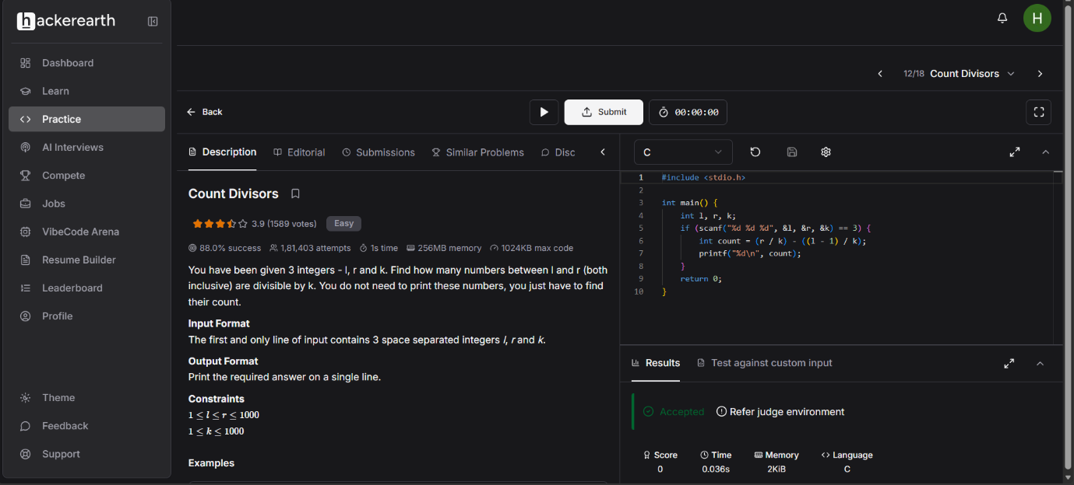
Successful Submission
Source Code


